8th Annual CESA 5 School-Based
Speech-Language Pathology Institute

Kalahari Resort & Convention Center
March 8-9, 2010

Conference Info

Speaker Change: Due to illness, Dr. Judy Montgomery is unable to speak 3/8/2010.
Pam Marshalla will present at Dr. Montgomery’s scheduled sessions.

Sunday, March 7, 2010
4:00 - 7:00 PM Early Check-in

NEW! On-line registration Credit cards now accepted.
www.myquickreg.com

NEW! Vendor exhibits open Monday 4:30-6:00 PM.

NEW! 30 minute breaks.

1 Viterbo graduate credit available for additional $200 for tuition and fees.

11 ASHA CMHs.

Registration limited to 500.

State rate lodging available at Kalahari for conference participants: $70/single, $119/double/tri/quad. No advance payment required.
State rates only apply for reservations until CESA 5 lodging block is filled or until February 5, 2010.
Call (877) 253-5466

Monday, March 8, 2010
7:30 - 8:30 AM Registration & Light Breakfast
8:30 - 8:40 AM Welcome and Overview
8:40 - 10:00 AM Pam Marshalla – 21st Century Articulation Therapy (Part I)
10:00 - 10:30 AM BREAK
10:30 - 12:00 PM Pam Marshalla – 21st Century Articulation Therapy (Part II)
12:00 - 1:00 PM LUNCH (provided)
1:00 - 2:00 PM Pam Marshalla – 21st Century Articulation Therapy (Part III)
2:00 - 2:30 PM BREAK
2:30 - 4:00 PM Mary Joslin – What Does Preschool Options Mean to Us?
4:00 - 4:30 PM Super Duper Publications Presentation
4:30 - 6:00 PM Speaker "Meet & Greet", Vendor Showcase, "Alumni"
Networking Reception

Tuesday, March 9, 2010
7:30 - 8:00 AM Registration & Light Breakfast
8:00 - 9:30 AM Dr. Barbara Davis – Assessment and Intervention Issues in
Childhood Apraxia of Speech: Identification/Assessment Issues
9:30 - 10:00 AM BREAK
10:00 - 11:00 AM Dr. Barbara Davis – Assessment and Intervention Issues …
Intervention Issues
11:00 - 12:00 PM Casey O'Keefe – Collaborating to Create Classroom
Conversations in Early Literacy Instruction (Part I)
12:00 - 1:00 PM LUNCH (provided)
1:00 - 2:45 PM Casey O'Keefe – Collaborating to Create Classroom
Conversations in Early Literacy Instruction (Part II)
**EARLY BIRD PRICING**

Professional
Both Days 1 Day
$215 till 2/15 $120 till 2/15
$240 after 2/15 $135 after 2/15
FT Student/Parent
Both Days 1 Day
$135 $85

2:45 - 3:15 PM GRAND PRIZE Drawings & Wrap-Up

FEATURED PRESENTERS
Pam Marshalla, MA, CCC-SLP – Marshalla Speech & Language, Mill Creek WA
Mary Joslin, MS – CESA 10, Chippewa Falls WI
Barbara L. Davis, PhD – The University of Texas at Austin
Casey O'Keefe, MS, CCC-SLP – Cardinal Stritch University, Milwaukee WI

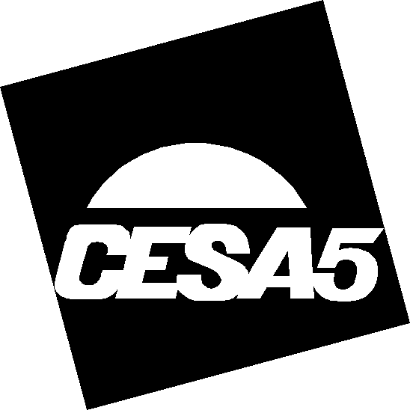
For more information please contact Dallas Kerzan, 608-742-8814, Ext. 246, kerzand@cesa5.k12.wi.us
Additional conference information at: www.cesa5.k12.wi.us/departments/sped_staffdevel.cfm

